Width and GRID http://RogerPf.com/aaBridge
A fix for systems that do not 'look good'.
aaBridge runs on Java. This way the same code will work on Win, Mac and Linux. However, there are a number of different suppliers and versions of Java. Often the fonts they include or the fonts that they use from the host Operating System vary. This can cause aaBridge to look different (not very good) on some systems.
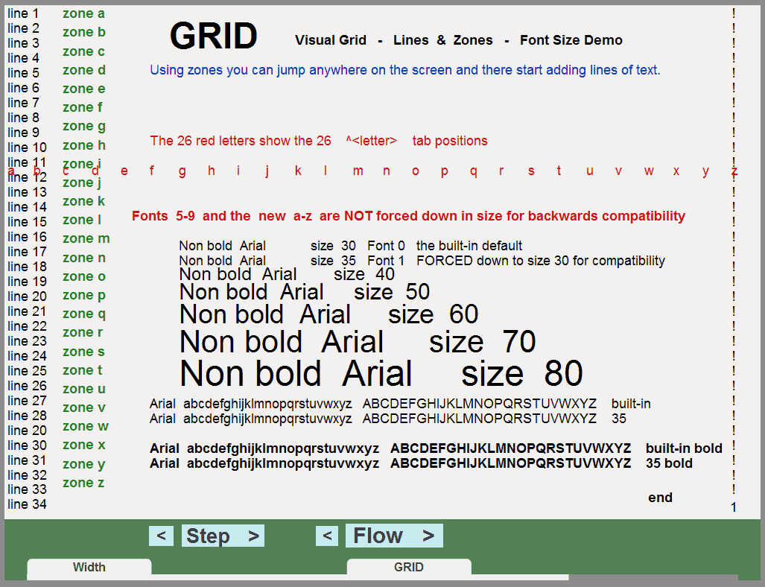
At the time of writing, the system most effected is Linux.
In the left hand column of the aaBridge Welcome page is the entry
Size Position Grid.
The 3rd page of that lin file shows the 'GRID'. On the 'well set up' system it should look as shown.
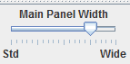
The key issue is that sometimes the standard font can be too wide. To get around the distortions that this causes you can set the main aaBridge window to be wider. This is done with the 'Main Panel Width ' slider.
Here is it shown set for Linux. The combination of adjusting that slider and changing the height and width of your aaBridge window will let you get a close match (except for the width) to the image shown above. (You may need to flip to another page and back after a slider adjustment.)
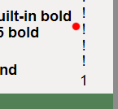
The two key places to check for a 'well set up' system are the bottom left and bottom right-hand corners.
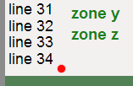
Here they are shown enlarged. In each case a red dot is visible next to a gap. Ideally the two gaps should be as shown, or very near that. (Having extra space on the right is OK).

Suggestion
Find up to 3 different sizes, each of which looks good on your system and Save them using the A B C buttons. Read page 1 of Size Position GRID.
<end of document>

